Artificial Intelligence  
Lab Exercise 8  
Learning Algorithm

short line

Ashwin Prakash  
RA1911026010048

**Aim:**

To implement a Learning Algorithm

**Problem Statement:**

To implement a traditional Machine Learning algorithm on a real-life dataset

**Algorithm:**

**Support Vector Machines (SVMs)**

1. Generate hyperplanes which segregates the classes in the best possible way. There are many hyperplanes that might classify the data. We should look for the best hyperplane that represents the largest separation, or margin, between the two classes.
2. So, we choose the hyperplane so that distance from it to the support vectors on each side is maximized. If such a hyperplane exists, it is known as the ***maximum margin hyperplane*** and the linear classifier it defines is known as a ***maximum margin classifier***.
3. If the data points are dispersed, linear separation is not possible. Therefore SVM uses a *kernel trick* to transform the input space to a higher dimensional space and then segregate the data points using linear separation

Kernel Function,

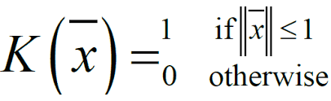

**Program:**

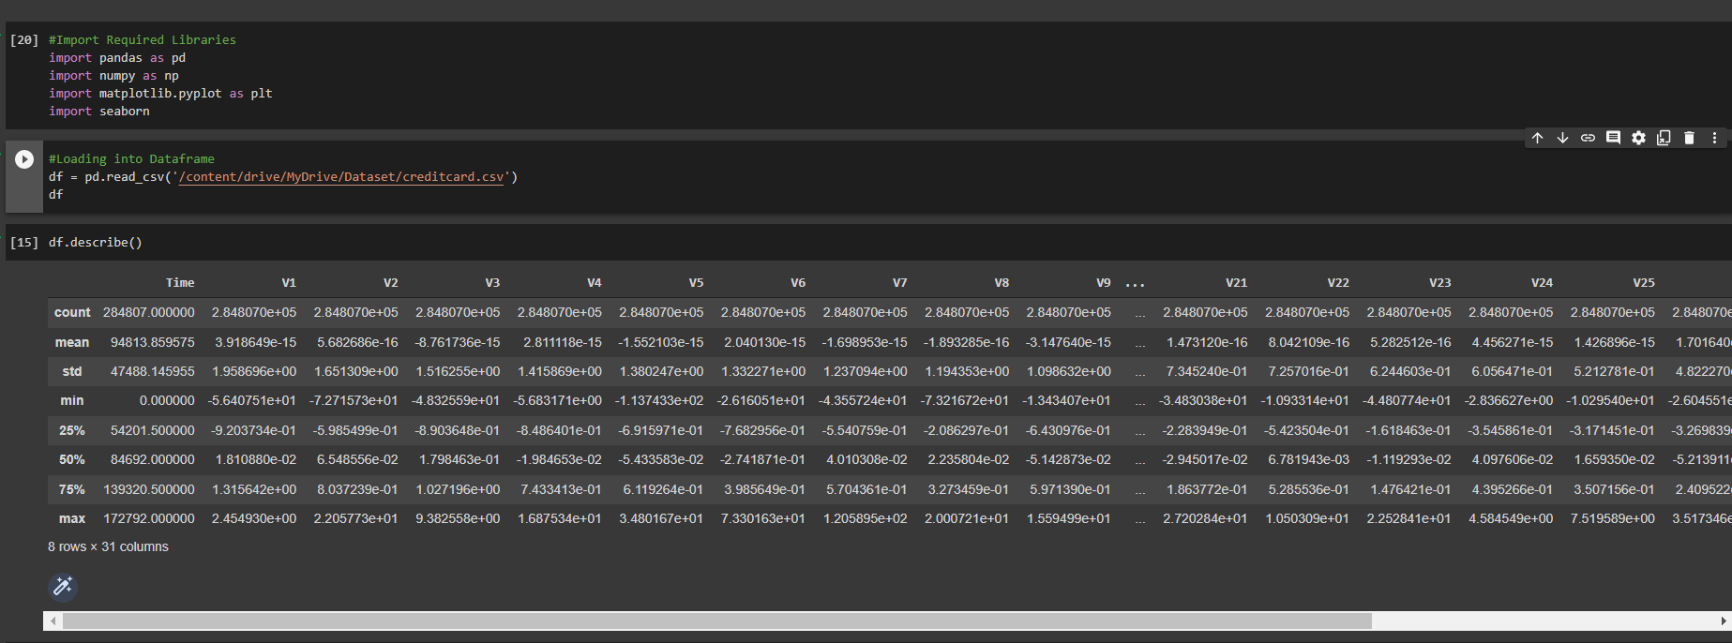

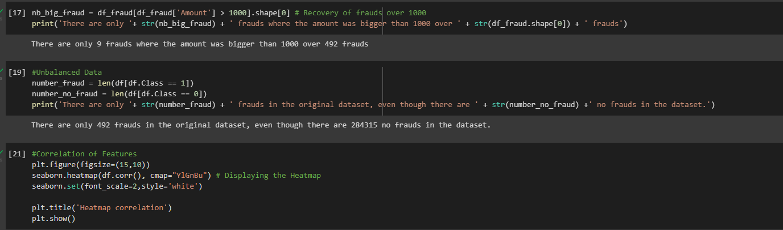

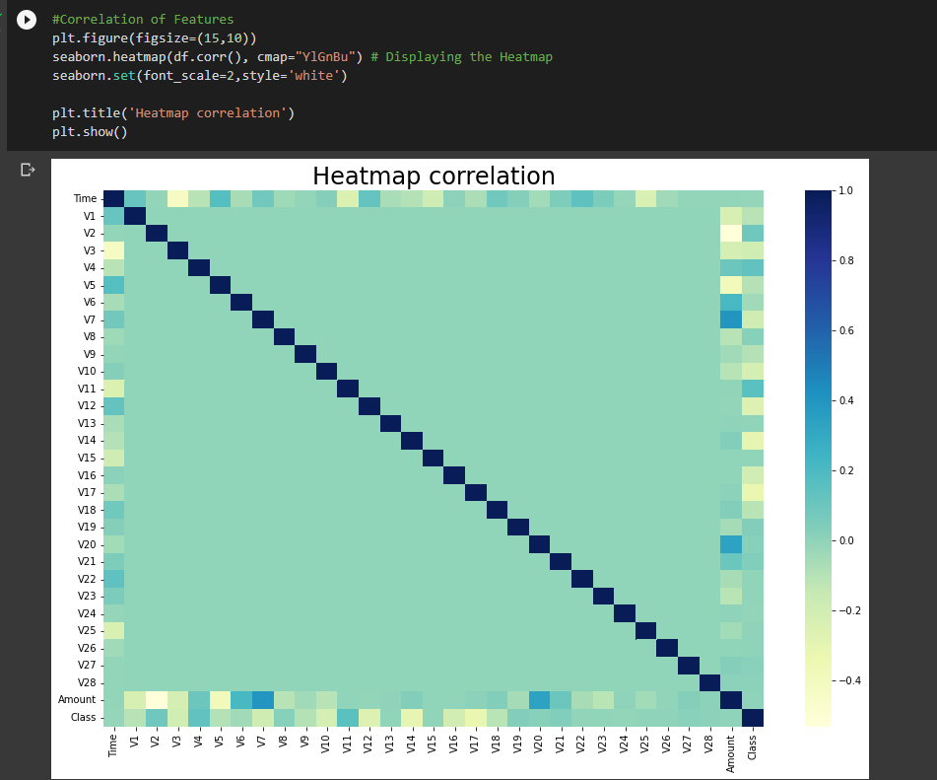

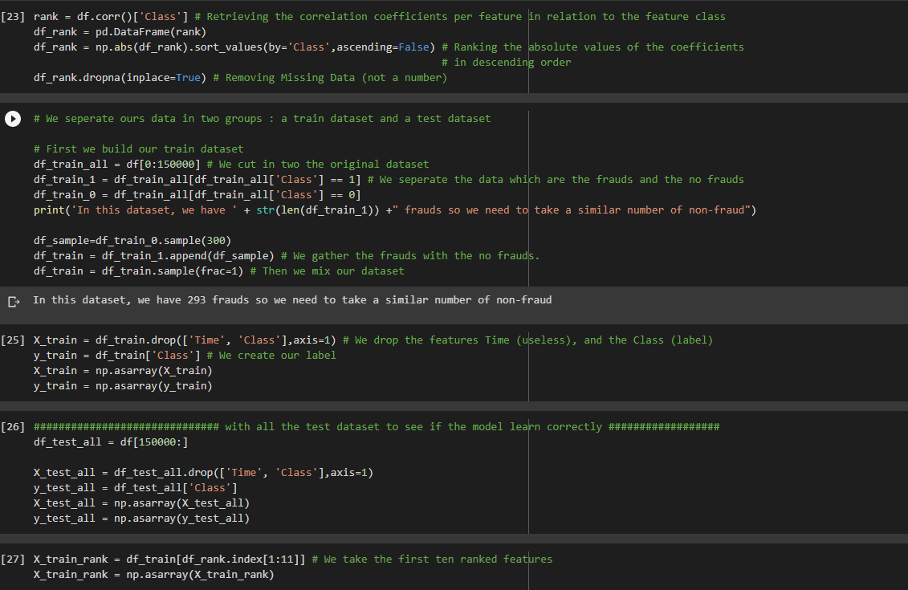

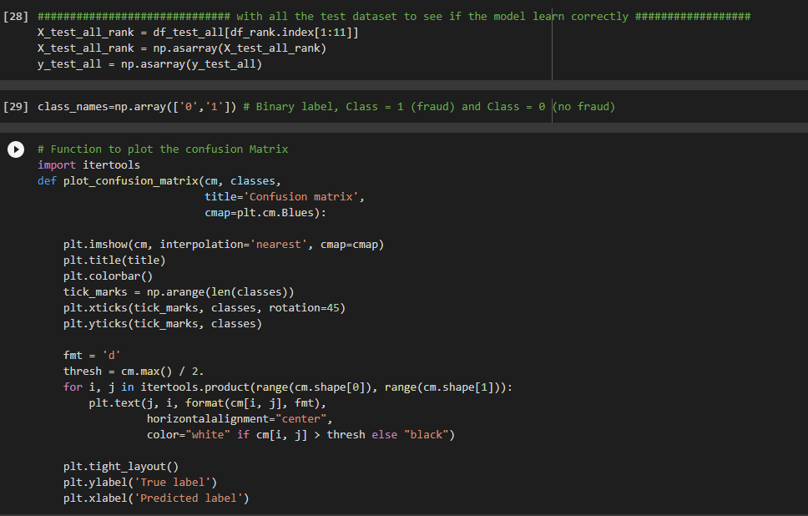

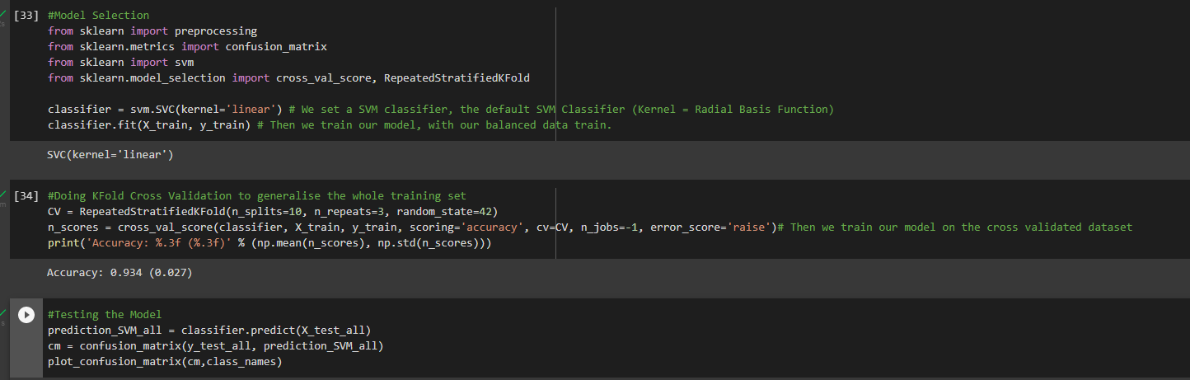

**Output:**

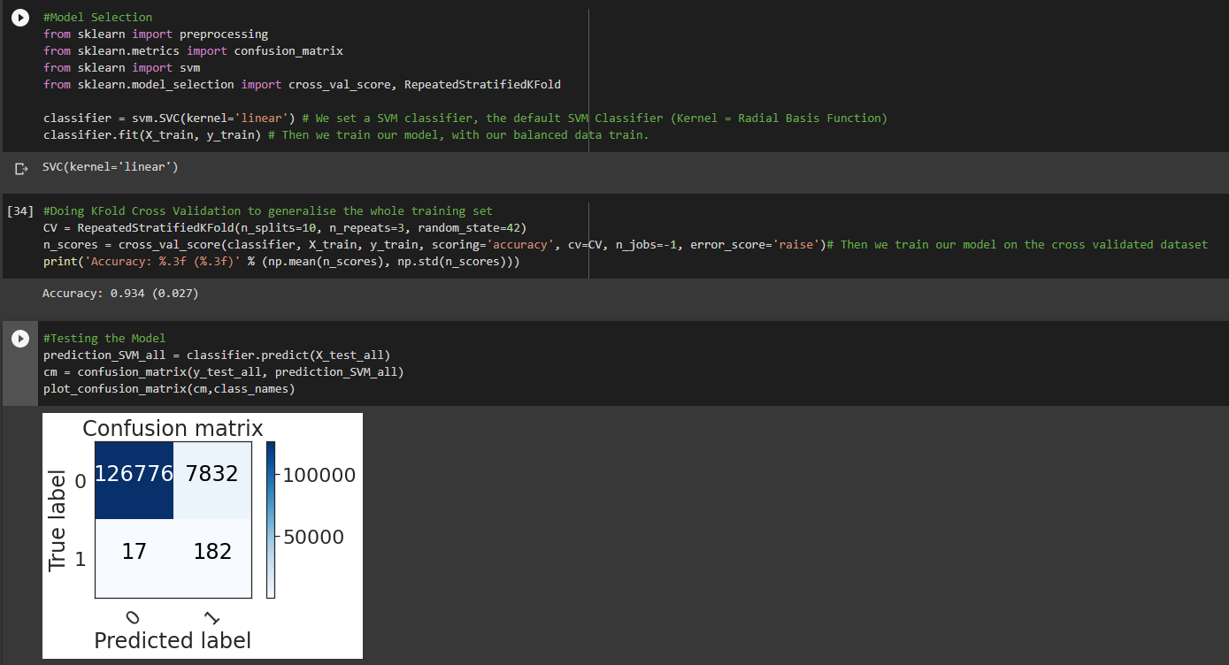

**Observations:**

1. SVM when selecting kernels tries to map the data to higher dimensional space so as to segregate the data.
2. Performing Cross Valisdation on the dataset shuffles the dataset hence giving different accuracy and the mean accuracy will always be lower than the best accuracy.
3. C parameter in SVM tells us how much we want to avoid misclassifying each training example. Large values of C optimizes algorithm with smaller margin hyperplane and very small values of C optimizes algorithm for larger margin hyperplane.

**Inference:**

The SVM Learning Algorithm has been successfully implemented on a real-life usecase.

**Result:**

Learning Algorithm problem is implemented successfully.